# Introduction

## Acknowledgement

## Abstract

## Introduction to the coursework

# Objectives

# Scope

We can begin the shaping of the designed system when considering the requirements needed for the work breakdown structure (WBS). (Edwards, 2020).

## Staff members of Food in Motion

User = employee.

Manager = handles supplier and customer details.

Beverage Supplier = supplies beverages.

Food Supplier = supplies food.

Delivery = delivers food and handles rest of the money.

These members will be of utmost importance for the completion of the e-catering system. The employee/user of the system will the main

role in the system. They will take in the orders given by the customers. The management/ manager will have the role of handling suppliers

and other main needed management roles. Since the system has to have the option of the down payment, the employee will have to deal with the payment as

well as the final person making the delivery to the customer. The remaining payment will be made to the person who makes the delivery. Therefore the

employee and delivery person have to interact and make sure the payments are up to pare.

## Customer

In the e-catering system, the customer has the ability to search for food and beverages in the menu from published e-catalogs.

The customer can change the menu according to their liking. The person ordering the food can compose a meal according to their liking, altering the available

menu and making a package for their liking. The person ordering the food has to make a down payment as soon as the meal is ordered to secure the order,

the rest of the payment is to be made once the delivery is done. This ensures that no fraud food orders will be placed.

## System

The system would generate monthly and daily reports.

The monthly reports that would be generated are:

1.Report including customer and supplier details.

2.Payment details per month.

3.Report about the food and beverage details.

4.Report of delivery details.

The daily report generated would be:

1.Daily income report.

The user will get a notification of confirmation of the down payment and the delivery details, which will allow them to track the location of the food package.

# Obstacles faced with manual E-catering system

By the time the customer receives the meal, it may have become cold.

The pictures in the app or on the website may appear to be delicious and enormous, but they are not.

Only when the user's device has access to the internet, he can use it.

Customer's preferences cannot be adjusted in the food recipe.

Customers may be concerned about the payment process's security.

When customers cancel their food orders, the restaurant may suffer a loss on the work they did.

# 5.Why are we going to use a Web based system?

Less time consuming

Convivence for staff members and customers.

Very safe and can rely on web-based system.

Advantages over external stages.

# Benefit of using the proposed system

One of the most significant advantages of e-catering is the time savings.

Increased revenue for e e-catering service providers, as customers find this approach to be more convenient.

24 hours a day, 7 days a week operation.

Can sample a wide range of foods.

Customers can also know about current food trends.

Customers can also read other people's reviews.

# System requirement development

With the aim of code generation, we've used a free and open-source UML (Unified Modelling Language) Diagramming Application named ArgoUML, written in Java and released under the open-source Eclipse Public License. (Anon., n.d.) ArgoUML is used for designing class diagram and such. Also, we have used Diagrams.net, a free and open-source cross-platform graph drawing software developed in HTML5 and JavaScript. (Anon., n.d.) Diagrams.net is used for designing sequence diagrams and collaboration diagrams and such

## Assumptions made to the system

The registration happens of E-catering system through the manager.

The registration of customer’s details is saved as Customer details when ordering happens.

If any unpredictable event occurs, the manager and employees can manually update the food and beverage availability.

Menu can be changed according to customer preference.

First the down payment should be done online, and the rest of the bill will be paid to the deliverer using cash once food gets delivered.

## Use Case Diagram

Use Case Diagrams emphasize the actors' and qualities' relationships and networks. The linkages and priorities can be grafted into a visually appealing display**.**

## Use Case Descriptions

### 7.3.1. Use case Login

|  |  |  |
| --- | --- | --- |
| Use Case No. | Uc-01 | |
| Use Case Name | Login | |
| Priority | High | |
| Actor | Manager, customer | |
| Description | If this use case is successful, the manager | |
| Pre-condition | None | |
| Post condition | Login success | |
| The fundamental course of action | User action | System responses |
| 1. Customer is on the Home page for login  3. Customer/Manager  enters user credentials and  clicks the login button | 2. System requests for login  credentials from Customer/  manager  4. System runs verification  on credentials  5. Manager/Customer  successfully logs in  6. Use case exit |
| An alternative course of action | 3.1. If user credentials are incorrect or not valid, the program will pop a message for validation and would allow re-filling of credentials, resuming back to stage 3 | |

### 7.3.2. Use Case Registering

|  |  |  |
| --- | --- | --- |
| 1. Use Case No. | Uc-02 | |
| Use Case Name | Registering Customer | |
| Priority | High | |
| Actor | Manager | |
| Description | This use case allows the manager to register customers. | |
| Pre-condition | Uc-01 | |
| Post condition | Manager has successfully deleted the item | |
| The fundamental course of action | User action | System responses |
| 1. Manager asks customer for personal details to register them.  2. Customer fills needed information to register.  5. Customer confirms the inputted details. | 3. System takes in details and asks user to confirm.  4. System generates message for customer to confirm details.  6. System successfully registers customer.  7. Use case exit |
| An alternative course of action | If in 4. user fails to confirm details entered as correct the system will re-direct to stage 3. | |

### 7.3.3 Use Case Update Order Details

|  |  |  |
| --- | --- | --- |
| Use Case No. | Uc-04 | |
| Use Case Name | Update Item | |
| Priority | High | |
| Actor | Customer/Manager/Employee | |
| Description | This use case allows the manager to update items | |
| Pre-condition | Uc-06 | |
| Post condition | Customer has successfully updated the item | |
| The fundamental course of action | User action | System responses |
| 1. User has option to update  Menu items.  2. User chooses needed items to be updated.  5. User clicks on update and affirms the request. | 3. System responds with options to update.  4. System generates message to confirm.  6. System updates and displays updated message.  7. Use case exit |
| An alternative course of action | If in stage 4 user fails to confirm deletion the system will re-direct to stage 1. | |

### 7.3.4. Use Case View Order Details

|  |  |  |
| --- | --- | --- |
| Use Case No. | Uc-0 | |
| Use Case Name | Viewing order. | |
| Priority | High | |
| Actor | Customer, manager | |
| Description | The actor can choose to view ordering made and all details in  relevance to the orderings | |
| Pre-condition | Uc-01, | |
| Post condition | A list of all orderings made is displayed in format | |
| The fundamental course of action | User action | System responses |
| 1. Customer/manager  is on view ordering page  [Based on actors, customer would  see his/her orderings, while  administration would be able  to see all orderings]  2.2. In case of administration, manager fills in ordering ID or  just views all orderings | 2. System displays relevant  orderings according to actors  2.1. In case of  administration, he/she can  view orderings according to  ordering D automatically  generated or all orderings  3. Orderings are displayed  4. System displays  confirmation of retrieval  5. Use case exit |
| An alternative course of action | 2.2.1. In case of manager filling ordering ID, if it is invalid the  system would validate and pop an error while re-directing to  stage 2.2 | |

### 7.3.5. Use Case Search Menu and Choose Order

|  |  |  |
| --- | --- | --- |
| Use Case No. | Uc-04 | |
| Use Case Name | Select an Item and search it, also ability to choose order. | |
| Priority | High | |
| Actor | Customer | |
| Description | Customer can Search items | |
| Pre-condition | Uc-06 | |
| Post condition | Customer has successfully Select the item | |
| The fundamental course of action | User action | System responses |
| 1. Actors are on the page that enable a search option  2. Actors select type of item  5.Customer accepts confirmation. | 3. System display available items  4. System requests filtering on type of item.    5. System confirms and validates item.  6. Use case exit |
| An alternative course of action | If at 5, customer does not accept confirmation it reverts back to 2. | |

### 7.3.7. Use Case Online Payment

|  |  |  |
| --- | --- | --- |
| Use case No. | Uc-08 | |
| Use case name | Payment from customer. | |
| Priority | High | |
| Actor | Customers | |
| Description | This use case allows the users/customer to pay through online. | |
| Pre-condition | Uc-06, Uc-07, Uc-05 | |
| Post-condition | User has successfully paid for the item online. | |
| The fundamental course of action. | User Action | System Responses |
| 1. User is on payment details page. 2. User enters payment details.   5.User confirms payment details.  7.customer hands over cash to person making delivery. | 3.system validates user information details.  4.system asks user to confirm.  6.System proceeds to make the online payment successfully.  7.use case exit. |
| The alternative course of action. | If in 3. Details are not validated the payment doesn’t proceed. | |

### 7.3.8. Use Case Generate Reports

|  |  |  |
| --- | --- | --- |
| Use case No. | Uc-08 | |
| Use case name | Generating daily reports | |
| Priority | High | |
| Actor | System | |
| Description | This use case allows daily reports for customer details, payment details food and beverage details, delivery details and daily income report. | |
| Pre-condition | Uc-06, Uc-07, Uc-05 | |
| Post-condition | Reports get generated successfully. | |
| The fundamental course of action. | User Action | System Responses |
| 1. System checks for all needed requirements to create reports. 2. System recovers needed details to make reports. | 3.Details will be differentiated and put into their reports.  4.Daily income and other details are generated.  5.Income and other details are generated successfully.  6.Use case exit. |
| The alternative course of action. | If no orders are made by customers within a day, the daily income report will be generated as null. | |

### 7.3.9. Use Case Delete Order

|  |  |  |
| --- | --- | --- |
| Use case No. | Uc-08 | |
| Use case name | Delete Order | |
| Priority | High | |
| Actor | Customer | |
| Description | Customer deletes reserved order. | |
| Pre-condition | Uc-06, Uc-07, Uc-05 | |
| Post-condition | Reports get generated successfully. | |
| The fundamental course of action. | User Action | System Responses |
| 1. Customer is on view order screen, with option to delete the order. 2. Customer decides to delete order and clicks on delete order button. 3. Customer confirms delete order. | 3.System responds to delete order.  4.System asks for a confirmation for deleting order.  5.System cancels the order and displays that order was successfully cancelled.  6.Use case exit. |
| The alternative course of action. | If in stage 4, customer doesn’t confirm deletion it will revert back to stage 1. | |

### 7.3.10 Use Case Logout

|  |  |  |
| --- | --- | --- |
| Use Case No. | Uc-01 | |
| Use Case Name | Login | |
| Priority | High | |
| Actor | Manager, customer | |
| Description | If this use case is successful, the manager | |
| Pre-condition | None | |
| Post condition | Login success | |
| The fundamental course of action | User action | System responses |
| 1. Customer is on the home page for login  3. Customer/Manager  enters user credentials and  clicks the login button | 2. System requests for login  credentials from Customer/  manager  4. System runs verification  on credentials  5. Manager/Customer  successfully logs in  6. Use case exit |
| An alternative course of action | 3.1. If user credentials are incorrect or not valid, the program will pop a message for validation and would allow re-filling of credentials, resuming back to stage 3 | |

### 7.3.11. Use Case Delete Item

|  |  |  |
| --- | --- | --- |
| Use Case No. | Uc-04 | |
| Use Case Name | Delete Item | |
| Priority | High | |
| Actor | Manager | |
| Description | This use case allows the manager to delete items | |
| Pre-condition | Uc-06 | |
| Post condition | Manager has successfully deleted the item | |
| The fundamental course of action | User action | System responses |
| 1. User is on updated items where the option for delete items are given  2. User clicks delete item button  5. User clicks confirm delete button & affirms request | 3. System responds to delete item request  4. System generates message to confirm deletion  6. System delete items & displays deletion message  7. Use case exit |
| An alternative course of action | If in 4. user fails to confirm deletion the system will re-direct to stage 1 | |

### 7.3.12. Use Case Supplier Payment

|  |  |  |
| --- | --- | --- |
| Use case No. | Uc-08 | |
| Use case name | Supplier Payment | |
| Priority | High | |
| Actor | Manager | |
| Description | This use case allows the manager to pay suppliers. | |
| Pre-condition | Uc-06, Uc-07, Uc-05 | |
| Post-condition | Manager has successfully paid for the item online. | |
| The fundamental course of action. | User Action | System Responses |
| 1. Manager is on payment details page. 2. Manager enters payment details.   5.manager confirms payment details | 3.system validates payment information details.  4.system asks manager to confirm.  6.System proceeds to make the payment successfully.  7.use case exit. |
| The alternative course of action. | If in 3. Details are not validated the payment doesn’t proceed. | |

### 7.3.13. Use Case Supplier Payment

|  |  |  |
| --- | --- | --- |
| Use case No. | Uc-07 | |
| Use case name | Physical Payment | |
| Priority | Medium | |
| Actor | Customers | |
| Description | This use case allows the users/customer to pay physically. | |
| Pre-condition | Uc-06, Uc-05 | |
| Post-condition | User has successfully paid for the item physically. | |
| The fundamental course of action. | User Action | System Responses |
| 1. Deliverer comes with package to given location. 2. Customer checks if order is correct.   5. Customer makes payment and takes package. | 1. Deliverer confirms order is correct. 2. Deliverer handles receipt to customer.   6. Deliverer takes  amount and hands over to manager. |
| The alternative course of action. | If at 2, the order comes out as incorrect, deliverer must confirm with manager and come back with proper ordered package. | |

### 7.3.14. Use Case Update Item

|  |  |  |
| --- | --- | --- |
| Use Case No. | Uc-04 | |
| Use Case Name | Update Item | |
| Priority | High | |
| Actor | Customer/Manager/Employee | |
| Description | This use case allows the manager to update items | |
| Pre-condition | Uc-06 | |
| Post condition | Customer has successfully updated the item | |
| The fundamental course of action | User action | System responses |
| 1. User has option to update  Menu items.  2. User chooses needed items to be updated.  5. User clicks on update and affirms the request. | 3. System responds with options to update.  4. System generates message to confirm.  6. System updates and displays updated message.  7. Use case exit |
| An alternative course of action | If in stage 4 user fails to confirm deletion the system will re-direct to stage 1. | |

### 7.3.15 Use Case Delete Item

|  |  |  |
| --- | --- | --- |
| Use Case No. | Uc-04 | |
| Use Case Name | Delete Item | |
| Priority | High | |
| Actor | Manager | |
| Description | This use case allows the manager to delete items | |
| Pre-condition | Uc-06 | |
| Post condition | Manager has successfully deleted the item | |
| The fundamental course of action | User action | System responses |
| 1. User is on updated items where the option for delete items are given  2. User clicks delete item button  5. User clicks confirm delete button & affirms request | 3. System responds to delete item request  4. System generates message to confirm deletion  6. System delete items & displays deletion message  7. Use case exit |
| An alternative course of action | If in 4. user fails to confirm deletion the system will re-direct to stage 1 | |

# 8.System Analysis and Domain Modelling

## 8.1 Functional View

## 8.1.1 Activity Diagram

The activity diagram in UML, also known as a behavioural diagram, is a graphical depiction of a group of conducted processes that depicts parallel and conditional activities, use cases, and functions. This diagram depicts the system’s control flow.

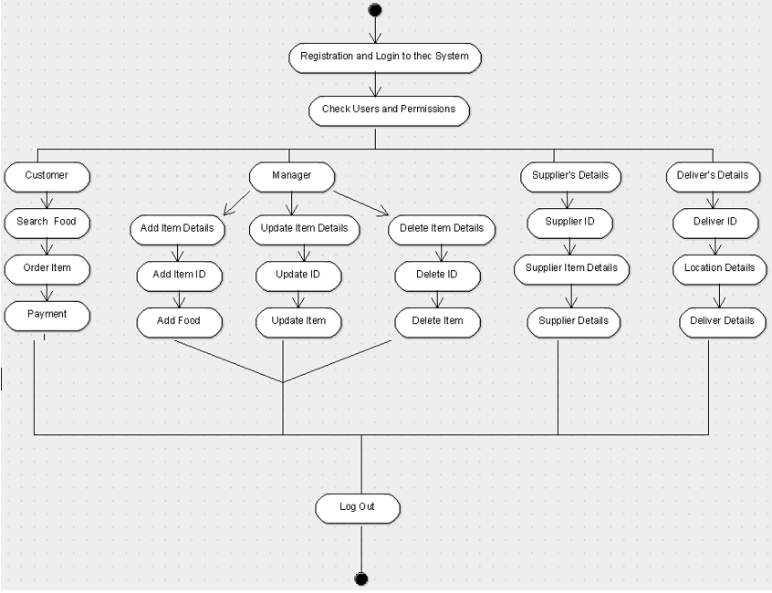

# State Machine Diagram

The state machine diagram, also known as the state chart diagram, is a behavioural diagram in UML that displays transitions between distinct objects. It is often used to represent state dependent behaviour of an item.

